Image Morphing Exercise
Dori Shapira, I.D. 033230095

Question 1
- The function has been written, and is pasted/attached/etc.

- The result had been compared with Matlab’s bilinear, and it is bit exact.

Following are the original, bi-linearized and NN images:

Original  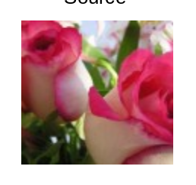 | Bilinear  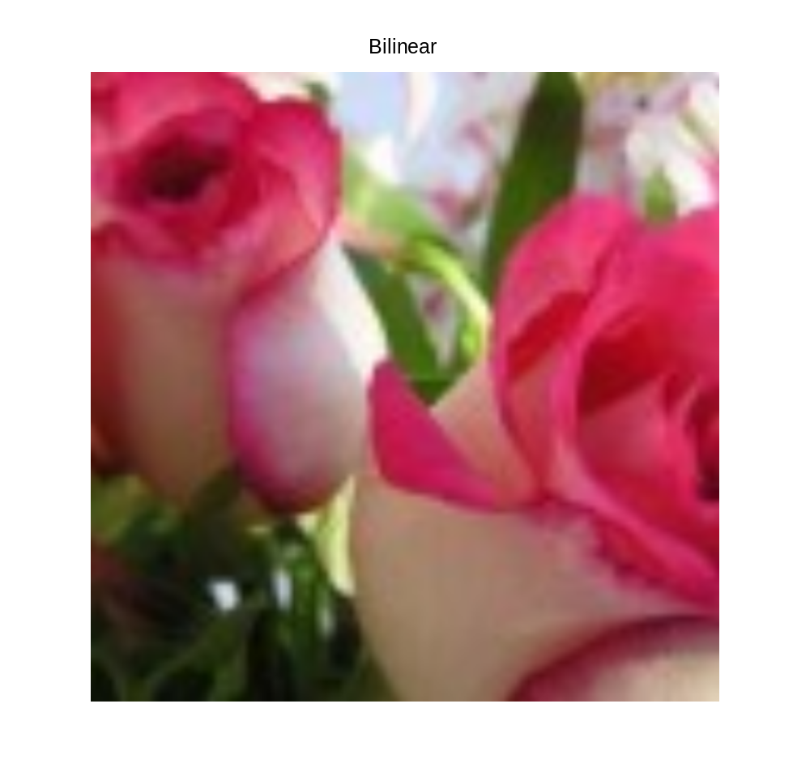 | Nearest Neighbor  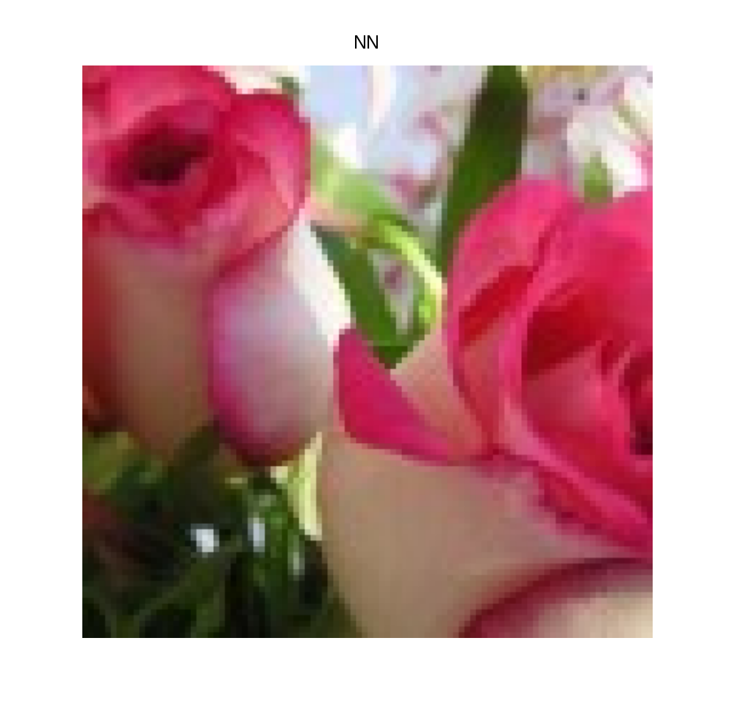

It is clear that the NN interpolation generates a “pixelized” image, the obvious explanation is that if we traveled along; say the “X” axis, in the interpolated image, we will stick to our nearest “source” pixel, until crossing the 50% distance between it the next pixel, thus generating a sharp edge (on perpendicular lines) on the mid way between “source” pixels.
In contrary, the bilinear method seems as if the pixels of the NN were smoothed (which is of course mathematically correct – smoothed by a triangular window)

Question 2
All functions had been implemented, but with some change in the defined API.

A tester had been implemented, and it looks like this:
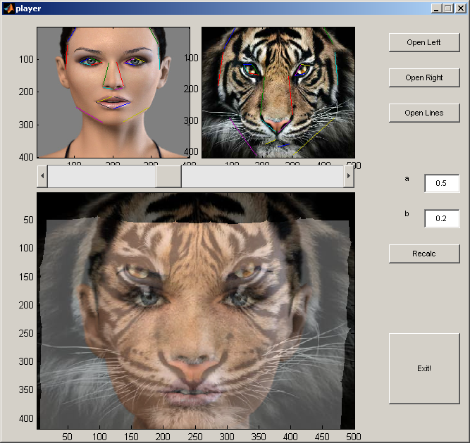
Changing the parameters a bit, causes the eyes to match:
